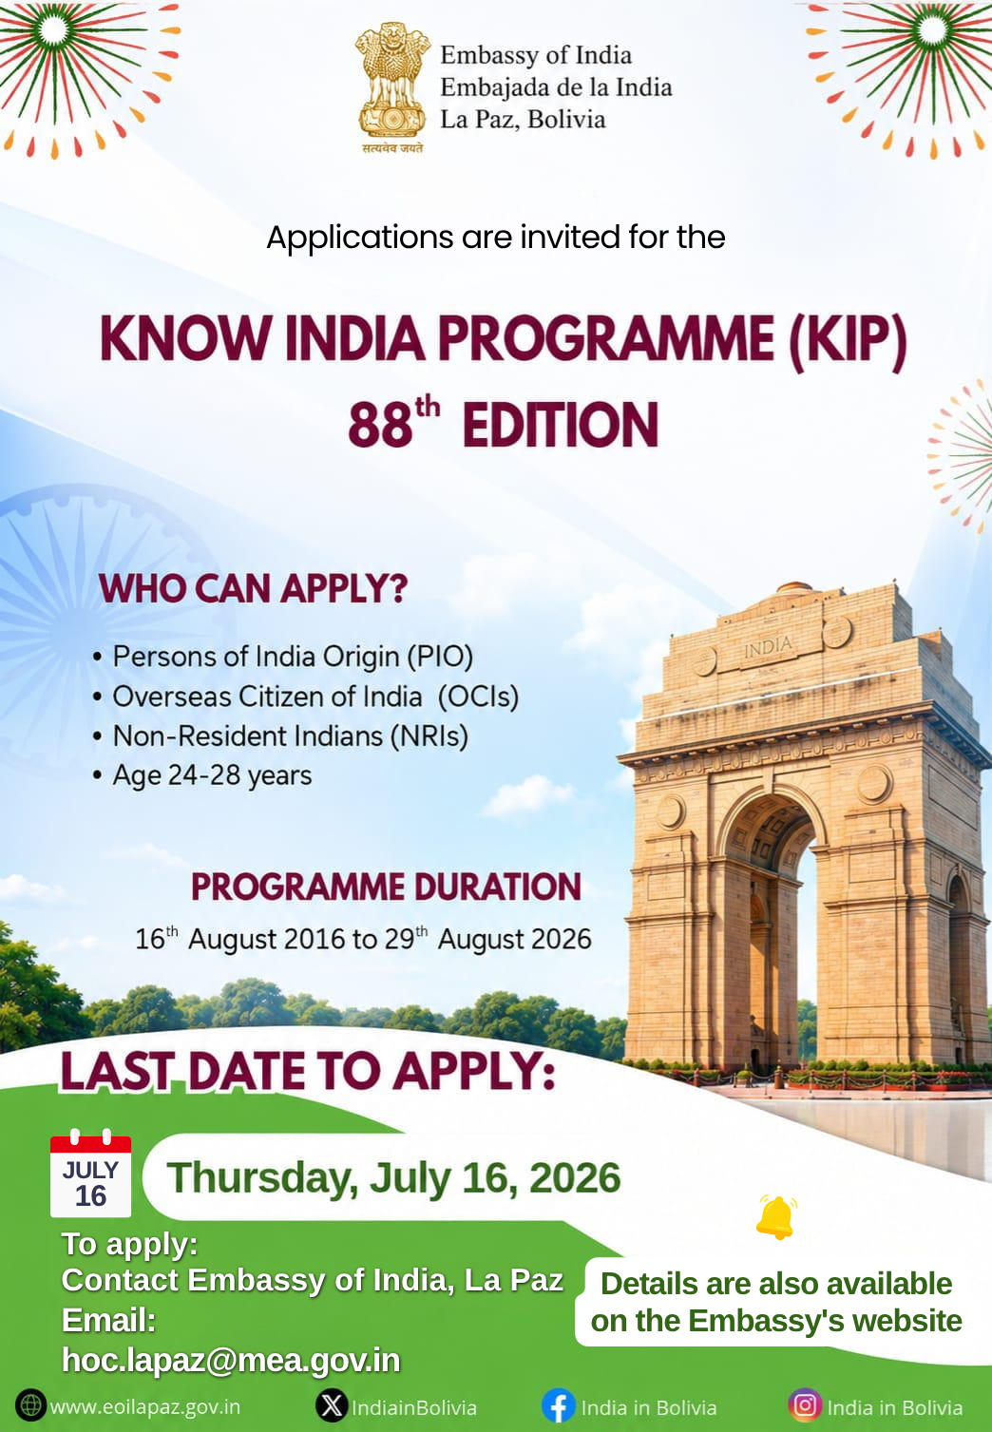
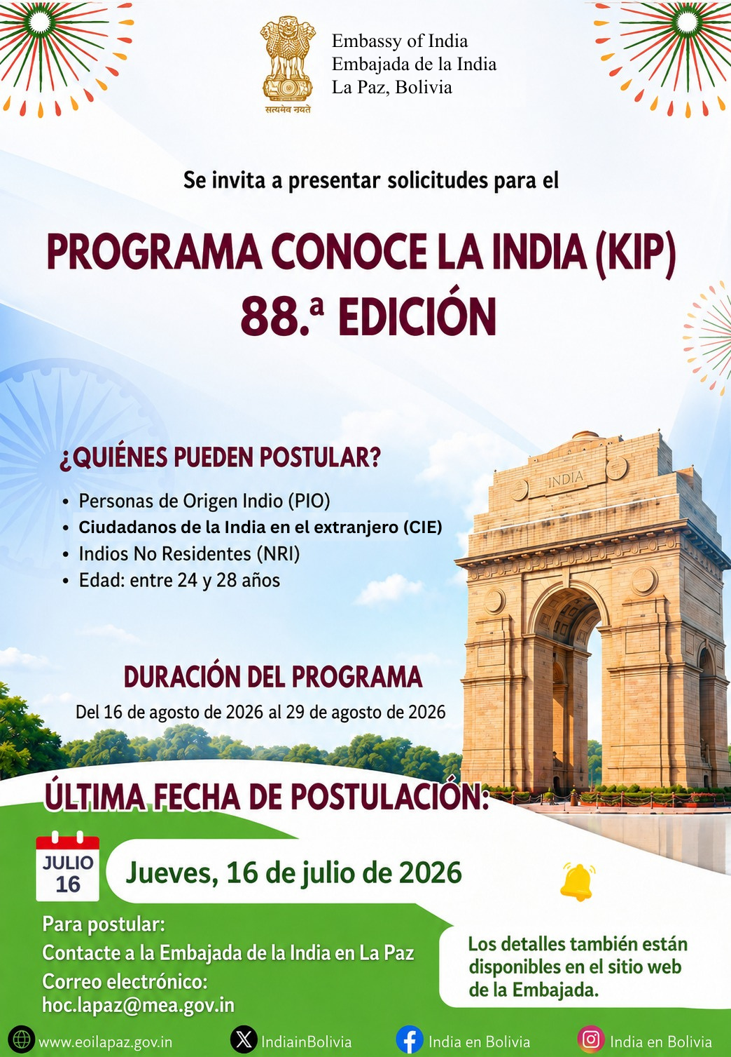
Government of India
Ministry of External Affairs
(Diaspora Engagement Division)
*****
GUIDELINES FOR KNOW INDIA PROGRAMME (KIP)
- INTRODUCTION
The Know India Programme (KIP), launched in 2003–04, is an engagement initiative of the Government of India with the youth members of the Indian diaspora with the view to strengthen their connect with their ancestral roots in India as well as to showcase and disseminate information pertaining to contemporary India’s spectacular growth and development in diverse domains as the country marches towards Viksit Bharat @2047. The objective of the Programme is also to motivate the Indian diaspora youth to participate in India’s developmental journey and contribute in all possible manner.
The KIP is a streamlined mechanism of the Government to engage with individuals of Indian origin between the ages of 18 and 28 years with specific differentiated focus on the two age categories: 18–23 years and 24–28 years, for which separate editions are conducted with the view to make the Programme more attractive and popular amongst the Participants. The Programme content for each of the above two cohorts of participants seeks to broadly familiarize the participants with India and promote awareness about diverse facets of the Indian life, cultural heritage, art and contemporary developments in the country.
The Programme is open to youth of Indian origin, including Persons of Indian Origin (PIOs), Overseas Citizens of India (OCIs), and Non-Resident Indians (NRIs), particularly those who have not previously visited India. Special preference is accorded to NRIs residing in the Gulf region, as well as participants from Girmitiya countries.
- MAIN ELEMENTS OF KIP
KIP is focused on dissemination of information pertaining to India’s contemporary polity, economy, history, culture, governance architecture, development trajectory and evolving global role. Its content has been specially curated to adapt to the distinct interests of the two cohorts, namely Scholars & Innovators (18–23 years) and Young Professionals (24–28 years).
Scholars & Innovators (18–23 Years)
- Exposure to India’s innovation and entrepreneurship ecosystem through interactions with start-ups, incubators, entrepreneurs and industry leaders, including institutions such as T-Hub, IITs, IIMs, ISRO, BARC and other premier scientific and research organisations.
- Interactive sessions and discussions on public policy, innovation, governance, economic development and flagship national initiatives such as Digital India, Skill India, Startup India and Aatmanirbhar Bharat.
- Immersion programmes and peer-learning opportunities through interactions with faculty, students, researchers and young innovators at prestigious universities, colleges, and institutes.
- Demonstrating India’s achievements across diverse sectors including Science & Technology, Information Technology, Space Research, Infrastructure, Digital Public Infrastructure, Education, Agriculture and Tourism.
- Visits to places of historical, cultural and civilizational importance, including iconic heritage sites such as the Red Fort, Qutub Minar, Taj Mahal, Khajuraho Temples, Konark Sun Temple, Bodh Gaya and the ghats of Varanasi, among others.
- Familiarisation with India’s rich cultural and civilizational heritage through exposure to Yoga, Ayurveda, classical music and dance, regional traditions and cultural performances.
- Visits to at least two States/Union Territories to provide participants with an immersive experience of India’s regional, linguistic and cultural diversity.
Young Professionals (24–28 Years)
- Exposure to key institutions of democracy, governance and policymaking such as the Parliament of India, Rashtrapati Bhavan, Election Commission of India, Reserve Bank of India, NITI Aayog, UIDAI, NPCI, and MP-IDSA, along with interactions with high dignitaries and policymakers.
- Showcase India’s achievements across diverse sectors including Science & Technology, Information Technology, Space Research, Infrastructure, Digital Public Infrastructure, Education, Agriculture and Tourism.
- Exposure to India’s innovation and entrepreneurship ecosystem
through interactions with start-ups, entrepreneurs and industry
leaders.
- Interactive sessions and discussions on public policy,
governance, economic development and India’s evolving global role.
- Visits to places of historical, cultural, and civilizational importance, including UNESCO and other iconic heritage sites across India.
- Exposure to India’s rich cultural and civilizational heritage through experiences in Yoga, Ayurveda, classical music and dance, regional traditions, and cultural performances.
- Visits to at least two States/Union Territories to provide participants with an immersive experience of India’s regional, linguistic and cultural diversity.
- ARRANGEMENTS
- Indian Missions/Posts will extend air passage for participants from their countries of residence to India and back, with Government of India bearing 90% of the airfare; the remaining 10% will be borne by the participants.
- Participants will also be provided local hospitality, including boarding/lodging in designated hotels and internal transportation within India, including airport transfers.
- Gratis visas will be issued to selected participants by the concerned Indian Missions/Posts abroad.
- ELIGIBILITY CRITERIA
- Age: The programme is open to youth of Indian origin, including Persons of Indian Origin (PIOs), Overseas Citizens of India (OCIs), and Non-Resident Indians (NRIs). Participants have been grouped into two cohorts based on age, namely ‘Scholars and Innovators’ and ‘Young Professionals’, with eligibility determined as on the first day of the month in which the programme is scheduled to commence.
- Scholars and Innovators: 18–23 years
- Young Professionals: 24–28 years
- PIO applicants must provide their OCI card number or PIO card number, or that of their parents or grandparents. In the absence of documentary proof of Indian origin, the applicants must submit a written undertaking affirming their Indian origin, duly attested by the DCM/DCG or the HOM/HOP of the concerned Indian Mission/Post.
- Non-Resident Indians (NRIs) are eligible to apply under the programme. Preference will be accorded to those who have not visited India previously. NRI applicants must provide proof of Indian citizenship/residency abroad to qualify for NRI status as prescribed by the Government of India.
- The Programme shall have a total intake of 25 participants per cohort in each edition, selected in accordance with the prescribed eligibility and selection criteria.
- Previous participation: The applicant must not have participated in any previous edition of the Know India Programme or in any other programme organized and funded by the Ministry of External Affairs, or by any other Ministry/Department of the Government of India or a State Government in India.
- Educational Qualification: The minimum qualification required for participants in the “Scholars and Innovators” cohort is 12th Class Graduation from a school/institution recognized by the host Government. The minimum qualification required for participation of “Young Professionals” cohorts in the Programme is Graduation from a recognized University/Institute.
- Language: Applicants must be proficient in spoken English and should have either studied English as a subject at the High School level or completed their undergraduate education with English as the medium of instruction.
viii. The applicants who have not visited India before will be given preference.
- DURATION
Separate editions of the Programme will be conducted for the two distinct cohorts with each edition comprising of 25 participants, as follows:
- 18–23 years: Scholars and Innovators (2 weeks including travel time, 25 participants)
- 24–28 years: Young Professionals (2 weeks including travel time, 25 participants)
- INTERNATIONAL MEDICAL AND TRAVEL INSURANCE
All KIP participants will be required to submit a valid comprehensive international travel and medical insurance policy covering the entire duration of their stay in India.
- SUBMISSION OF PROGRAMME REPORT BY THE SELECTED PARTICIPANTS
For successful completion of the KIP, participants will be required to submit a 750–1000-word Programme Report outlining their experiences and insights gained during the programme. The report shall comprise of key takeaways of the KIP and how the programme has helped the participants acquire a better understanding of contemporary India and its rich cultural legacy.
Participants will be awarded certificates upon completion of each edition of the programme.
*****

GOVERNMENT OF INDIA
MINISTRY OF EXTERNAL AFFAIRS
NEW DELHI

APPLICATION FORM FOR KNOW INDIA PROGRAMME (KIP)
 |  |  | Attach Recent Passport size photo
KIP Edition No. |  |  | Attach Recent Passport size photo
Note: Candidates are requested to attach all required documents such as Passport Copy, Educational Qualification Certificate, PIO/OCI/NRI Certificate/Annexure-C, Passport Size Colored Photograph & other relevant documents with this Application before forwarding the same to the Indian Missions/Posts concerned.

A. PERSONAL DETAILS
(i) Complete Name (as in Passport in BLOCK letters)

______________________________________________________________
First Name Middle Name Last Name
(ii) Gender: Male/Female
D | D | M | M | Y | Y | Y | Y
(iii) Date of Birth:
(iv) | Place of Birth
(v) | Nationality
(vi) | Place of Residence
(vii) | Passport Details
 | Passport No.
 | Place of Issue
 | (City, Country)
 | Date of Issue
 | Date of Expiry
(viii) | Telephone No. (With Country and City Code)
 | Work
 | Residence
 | Mobile/Cell
 | Whatsapp No.
 | Fax No.

Email: _______________________________________________________________

(ix) Complete mailing address with ZIP Code: ___________________________________________________________________________ ___________________________________________________________________________
(x) Permanent home address with ZIP Code: ______________________________________________________________________________________________________________
(xi) Your or your parents place of origin in India : ________________________________

B. Proof of Indian Origin

Hold PIO/OCI Card/NRI Certificate - Yes/No

PIO Card No:_______________Date of Issue______________Place of issue______________
OCI Card No:_______________Date of issue______________Place of issue______________
NRI Certificate No:____________Date of issue_____________Place of issue______________
Please write details of PIO or OCI Card of your Mother/Father/Grandfather________________
Name of PIO/OCI Card holder____________________________________________________

C. Details of Family/Relative(s) in India
(i) Name, address (if available) and your relationship with your nearest relative who migrated from India:
(a) Complete Name
(b) Last Known address of your relative
(c) Your relationship with him/her
(d) Mobile number of your relative with city code
D. EDUCATION
 |  | Graduate | Undergraduate | Class 12
(i) | Name/Location School/College/University from where you graduated or are studying.
(ii) | Subjects of study
(iii) | Language of instruction in school/ college/university
(iv) | Describe your English language skills

E. Occupation/Employment:
S. No. | Organization/Company (Complete Name and Location address) | Position | Period
S. No. | Organization/Company (Complete Name and Location address) | Position | From | To

F. Any achievements professional/educational or other that you want to share with us: __________________________________________________________________________________________________________________________________________________________________________________________________________________________________________________________________________________________________________________________________________________________________________________________________________________________________________
G. Your interests/hobbies___________________________________________________ ____________________________________________________________________________________________________________________________________________________________________________________________________________________________________________________________________________________________

H. International Medical and Travel Insurance Policy
Policy No. –
Name of the insurance company –
Valid from (Date) –
Valid until –

Annexure-A
I. OTHER DETAILS:
- Have you participated in a previous
Know India Programme? If yes, provide details. Yes / No

- Have you visited India earlier? If yes, Yes / No
please month and year of the visits, places
visited and purpose:

- Has any sibling/ relative of yours attended KIP before Yes / No

- Please describe, in not more than 250 words, why do
you want to take part in the Know India Programme?

Annexure-B
DECLARATION:
I, HEREBY, DECLARE THAT ALL THE INFORMATION GIVEN IN THIS Application Form are true and correct to the best of my information and belief.
I also declare that I will abide by the regulations of the Know India Programme, would offer my full cooperation in its smooth conduct, and would not leave it mid-way.
I understand that if I am found guilty of any misconduct or indiscipline during the course of the Programme, I could be refused any further participation in the said programme or participation in any future KIP and that I would not be eligible for reimbursement of the 90% of the return international airfare from my country of residence to India. The said reimbursement of 90% of the international airfare would also not be made to me if I leave the Programme mid-way.

(Signature of the applicant)
Date:
Place:

Annexure-C
DECLARATION
(For applicants who do not possess any documentary evidence of Indian Origin)

I __________________________________ (complete name) born on __________________________(Date of birth), daughter/son of _____________________
(Complete name) do hereby state that I am of Indian origin because of the following reasons:
_________________________________________________________________________________________________________________________________________________________________________________________________________________________________________________________________________________________________________________________________________________________________________________________________________________________________________________________________________________________________________________________________________________________________________________________________________________________________________________________________________________

Signature of the Applicant:_________________________
Complete Name:________________________________

Date:____________________
Place:____________________

Countersigned and stamped by
Head of Indian Mission or DCM/DHC/DCG

Complete Name:__________________________

Office Seal:_______________________________

Date:____________________
Place:____________________

